|  |  |  |
| --- | --- | --- |
| **MODULE:** 11 | **LESSON:** 4 | WRITING INEQUALITIES |

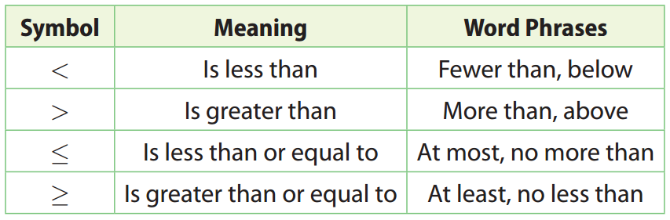

|  |  |  |
| --- | --- | --- |
| **Inequality** | **Meaning** | **Solution of Inequality** |
| *x* > 3 | All numbers greater than 3 | The *open circle* at 3 shows that the value 3 is **not** included in the solution.  6_MTXEDI065642_298T |
| *x* ≥ 3 | All numbers *greater*  *than or equal to* 3 | The *closed circle* at 3 shows that the value 3 **is** included in the solution.  6_MTXEDI065642_299T |
| *x* < 3 | All numbers less than 3 | 6_MTXEDI065642_300T |
| *x* ≤ 3 | All numbers less than or equal to 3 | 6_MTXEDI065642_301T |